**Kaif Ikhlaq**

**SU92 BSAIM S24 027**

**TASK 2**

* The code runs a Fizz Buzz game where the user chooses the number of rounds, and for each round, a random number is checked. It prints "Fizz" for multiples of 3, "Buzz" for multiples of 5, and "Fizz Buzz" for multiples of both 3 and 5.

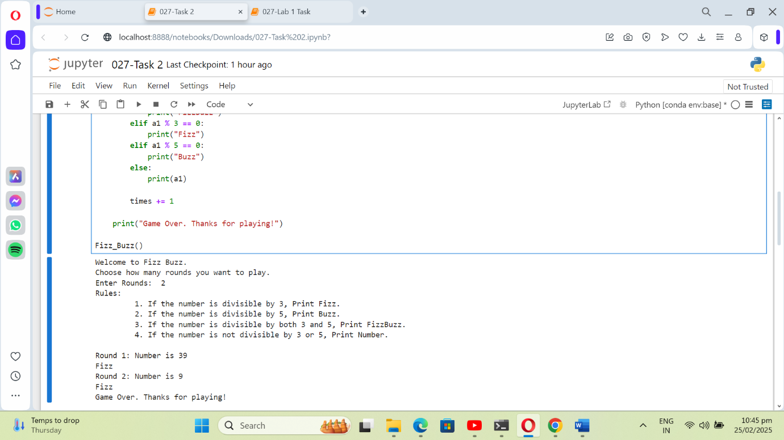

**Task 2**

* The code manages a movie database, allowing users to add movies with their budgets. It calculates the average budget and displays movies with budgets higher than the average.

